HOME PAGE STRUCTURE
Tasks
1.Create a simple wireframe sketch (on paper or using a free tool like Figma or Canva) for the home page of a food delivery app similar to Zomato, showing the main sections you would include and their layout.

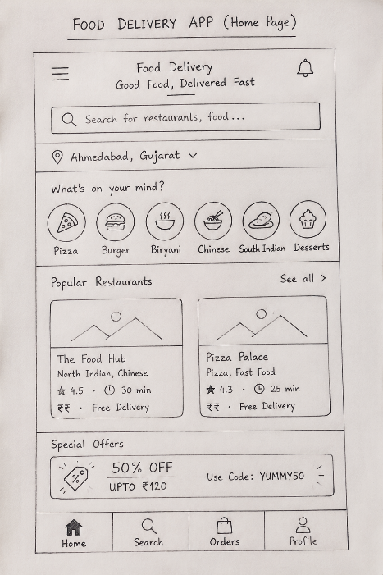

2.Design an HTML structure for a home page of a music streaming app like Spotify, including a header, navigation bar, featured playlists section, and a footer. Use only HTML, no CSS or images yet.

- Answer :
<!DOCTYPE html>
<html lang="en">
<head>
<meta charset="UTF-8">
<title>Music Streaming Home Page</title>
</head>
<body>

<header>
<h1>Music Stream</h1>
</header>

<nav>
<a href="#">Home</a> |
<a href="#">Playlists</a> |
<a href="#">Artists</a> |
<a href="#">Albums</a> |
<a href="#">Contact</a>
</nav>

<main>

<section>
<h2>Featured Playlists</h2>

<article>
<h3>Top Hits 2026</h3>
<p>Enjoy the latest trending songs.</p>
</article>

<article>
<h3>Chill Vibes</h3>
<p>Relax with peaceful music.</p>
</article>

<article>
<h3>Workout Mix</h3>
<p>High-energy songs for workouts.</p>
</article>

</section>

</main>

<footer>
<p>&copy; 2026 Music Stream. All Rights Reserved.</p>
</footer>

</body>
</html>

3.List 5 essential elements that should appear above the fold (visible without scrolling) on an e-commerce home page like Flipkart, and explain in one line why each is important.

Elements | Why it is Important
Search Bar | Helps users quickly find products.
Navigation Menu | Makes browsing different categories easy.
Bannner / Offers | Highlights discounts and attracts customers.
Login / Account | Allows users to access their account and orders.
Cart Icon | Lets users view and manage selected products.

4.Open the home page of any popular app you use (Instagram, Swiggy, BookMyShow, etc.) and note down the first three sections or features you see. Write a short paragraph on how the order of these sections helps user engagement.<br><br><em><strong>Hint:</strong> Think about what grabs your attention first and why.</em>

=> Answer :
- Instagram
- First Three Sections:
1. Stories
2. Reels / Feed Posts
3. Bottom Navigation Bar
- Paragraph:
The Instagram home page first shows Stories, which grab the user’s attention with recent updates. Next, the Feed and Reels display engaging content to keep users interested. The Bottom Navigation Bar allows users to easily access Search, Reels, Profile, and other features. This order increases user engagement by showing attractive content first and making navigation quick and simple.

